**연구 내용 : 6축센서(MPU-6050) 를 I2C로 라즈베리파이에 연결**

**날짜 : 2015.09.15.**

**작성자 : 김승일**

<i2c 설정하는 법>

1. raspi-config 에서 i2c를 enable

2. sudo apt-get install python-smbus

3. sudo apt-get install i2c-tools

4. sudo vi /etc/modules 에서

i2c-bcm2708

i2c-dev

두줄 추가 후 재부팅

5. sudo i2cdetect –y 1 (raspberry pi 1 의 경우, 0)

그러면 아래 사진처럼 확인됨.

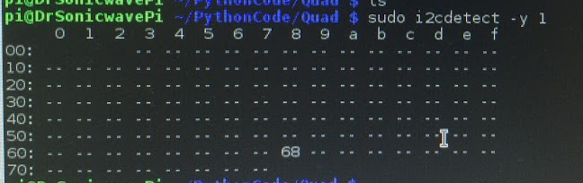

<MPU-6050 6축센서와 라즈베리파이의 연결>

사진 추가. 핀연결

동영상 첨부

코드추가. 코드링크 <http://gongnorina.tistory.com/77>

import smbus

import math

# Power management registers

power_mgmt_1 = 0x6b

power_mgmt_2 = 0x6c

def read_byte(adr):

    return bus.read_byte_data(address, adr)

def read_word(adr):

    high = bus.read_byte_data(address, adr)

    low = bus.read_byte_data(address, adr+1)

    val = (high << 8) + low

    return val

def read_word_2c(adr):

    val = read_word(adr)

    if (val >= 0x8000):

        return -((65535 - val) + 1)

    else:

        return val

def dist(a,b):

    return math.sqrt((a*a)+(b*b))

def get_y_rotation(x,y,z):

    radians = math.atan2(x, dist(y,z))

    return -math.degrees(radians)

def get_x_rotation(x,y,z):

    radians = math.atan2(y, dist(x,z))

    return math.degrees(radians)

bus = smbus.SMBus(0) # or bus = smbus.SMBus(1) for Revision 2 boards

address = 0x68       # This is the address value read via the i2cdetect command

while 1:

# Now wake the 6050 up as it starts in sleep mode

bus.write_byte_data(address, power_mgmt_1, 0)

print "gyro data"

print "---------"

gyro_xout = read_word_2c(0x43)

gyro_yout = read_word_2c(0x45)

gyro_zout = read_word_2c(0x47)

print "gyro_xout: ", gyro_xout, " scaled: ", (gyro_xout / 131)

print "gyro_yout: ", gyro_yout, " scaled: ", (gyro_yout / 131)

print "gyro_zout: ", gyro_zout, " scaled: ", (gyro_zout / 131)

print

print "accelerometer data"

print "------------------"

accel_xout = read_word_2c(0x3b)

accel_yout = read_word_2c(0x3d)

accel_zout = read_word_2c(0x3f)

accel_xout_scaled = accel_xout / 16384.0

accel_yout_scaled = accel_yout / 16384.0

accel_zout_scaled = accel_zout / 16384.0

print "accel_xout: ", accel_xout, " scaled: ", accel_xout_scaled

print "accel_yout: ", accel_yout, " scaled: ", accel_yout_scaled

print "accel_zout: ", accel_zout, " scaled: ", accel_zout_scaled

print "x rotation: " , get_x_rotation(accel_xout_scaled, accel_yout_scaled, accel_zout_scaled)

print "y rotation: " , get_y_rotation(accel_xout_scaled, accel_yout_scaled, accel_zout_scaled)